The 12th EU-China Business and Technology Cooperation Fair
Chengdu, 24-28 October 2017

Please complete the form and return to following contacts:
catherine_yang@eupic.org.cn john_li@eupic.org.cn

Hotel Reservation Form

Official Hotels :
1. 假日酒店Holiday Inn Chengdu Century City★★★★
208 West Tower, Century City Blvd., Chengdu, Sichuan, Chengdu, 610041, China
http://www.ihg.com/holidayinn/hotels/us/en/chengdu/ctuhi/hoteldetail

Room Rate |  |  | King | Qty | Twin | Qty
A | Classic Room  高级大床  26m² | 550RMB |  |  |  |  | 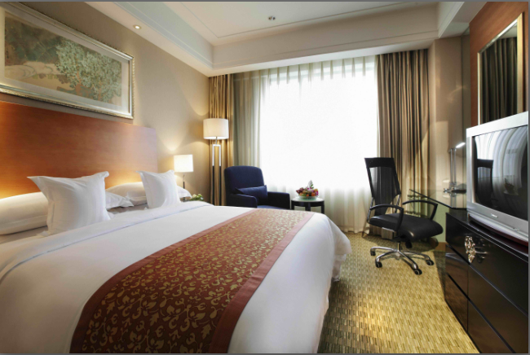
B | Deluxe Room  豪华大床  32m² | 650RMB |  |  |  |  | 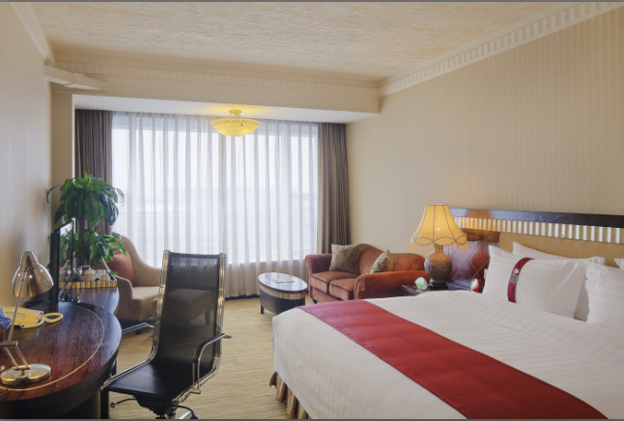
C | King Executive Room  行政单间  65m² | 750RMB |  |  |  |  | 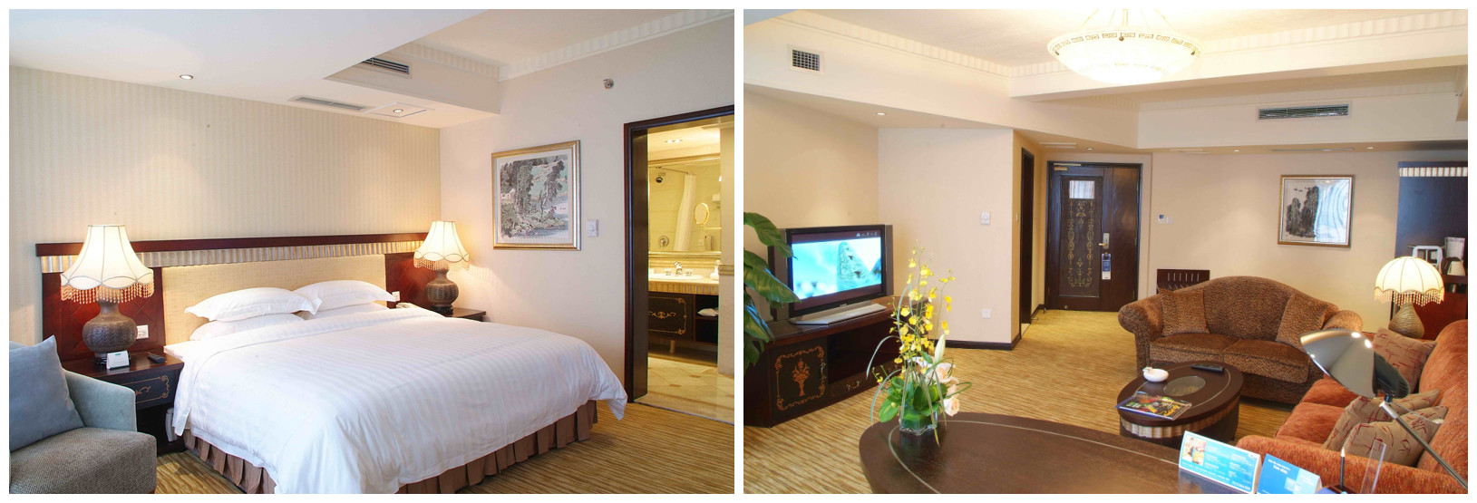

2. 洲际酒店InterContinental Century City Chengdu ★★★★★
88, CENTURY CITY BOULEVARD, Chengdu, 610041, China, People's Republic of
http://www.ihg.com/intercontinental/hotels/gb/en/chengdu/ctuha/hoteldetail

Room Rate |  |  | King | Qty | Twin | Qty
D | Deluxe Room  豪华大床  45-59m² | 950RMB |  |  |  |  | 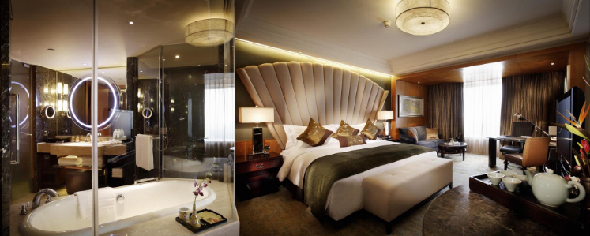
E | Executive Room行政大床  45-59m² | 1250RMB

Remark:
- Pay on arrival;
- Rates shown above are per room and night and include 15% of service charge, 1 or 2 daily breakfast and tax;
- Free internet connection.
- During the period of the fair, the Check-out time is before 14:00 noon. Any delay in checking out before 18:00 without the consent of the hotel will be subjected to a charge for another half day and that after 18:00 will be subjected to a charge for another full day.

Guest information (add additional guest info if necessary)
First Name |  | Family Name
Gender |  | Organisation
Country |  | Passport Number
Mobile |  | Email
Arrival Date |  | Arrival Flight
Departure Date |  | Departure Flight
Smoking Room | ( ) yes ( ) no | Other requirements

